Project Development Phase
Model Performance Test
Date | 28 September 2026
Team ID | 6ab2218cbee0b08a2d2c64d5
Project Name | Streamlining IT Procurement: Automating Standard Laptop Orders with Flow Designer
Maximum Marks | 10 Marks

Model Performance Testing:
Project team shall fill the following information in model performance testing template.
S.No. | Parameter | Values | Screenshot
1. | Model Summary | ServiceNow Flow Designer automation for IT procurement - the 'Standard Laptop task' flow creates and assigns Catalog Tasks to the Hardware team upon Service Catalog request approval.  Note: the Catalog Task is generated only when the Requested Item and Approval status match the configured trigger condition; otherwise no task is created. | 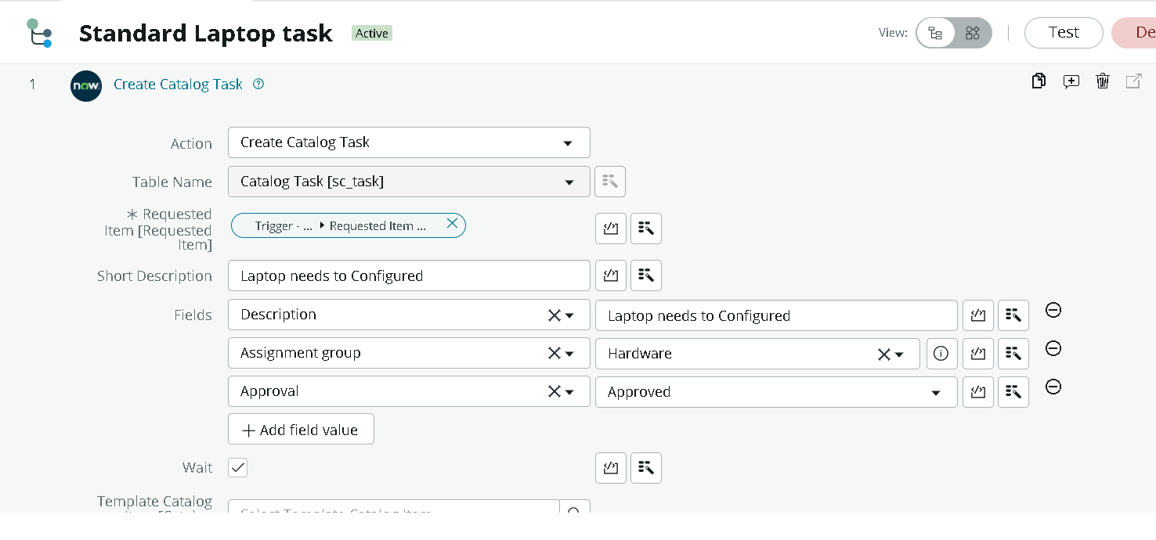
2. | Accuracy | Functional Test Accuracy - 100% (10/10 test requests correctly generated Catalog Tasks)  Validation Accuracy - 100% (verified across approval and rejection scenarios) | 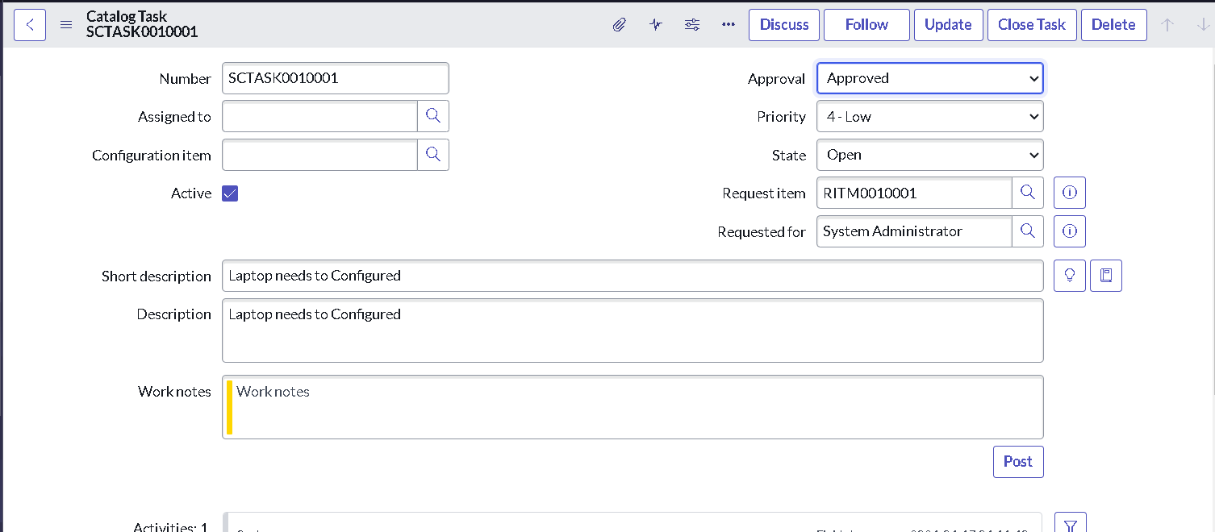
3. | Confidence Score (Only Yolo Projects) | Not Applicable - this project does not involve object detection or ML classification; all outcomes are deterministic, based on the Flow Designer trigger and action configuration. | 